Super keyword->

The **super** keyword in java is a reference variable which is used to refer immediate parent class object.

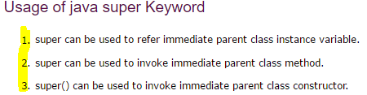

1) super is used to refer immediate parent class instance variable.

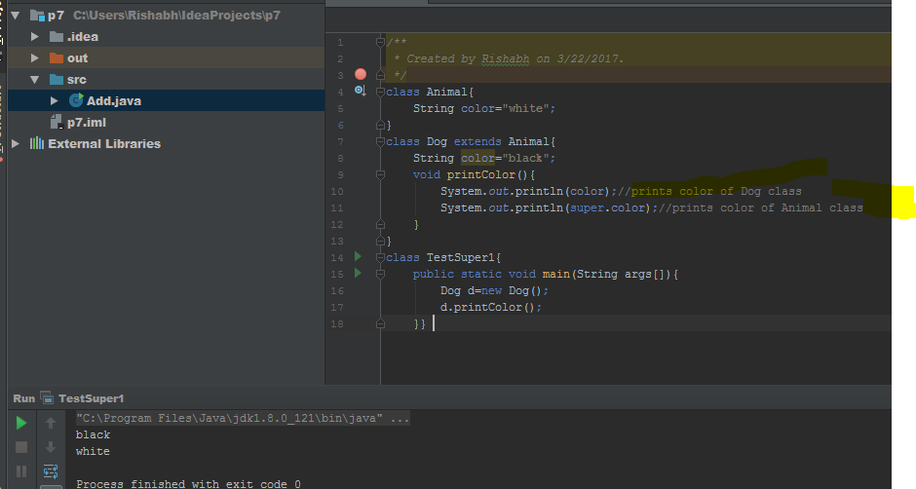

## 2. super can be used to invoke parent class method

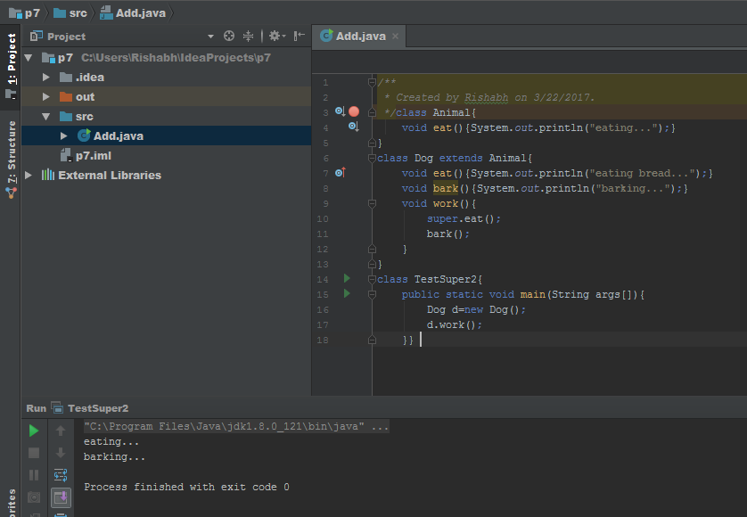

## 3.  super is used to invoke parent class constructor.

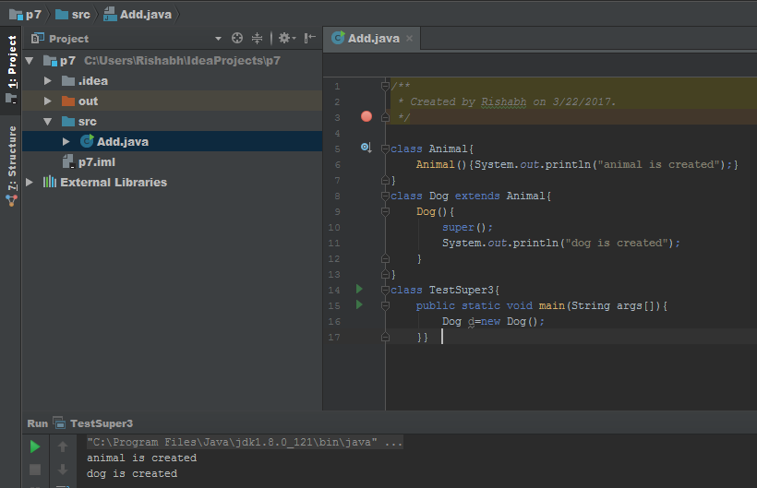

#### ##Note: super() is added in each class constructor automatically by compiler if there is no super() or this().

